**Daily Assignment-4**

Name: **Harish Er**

1. **Creating Databases, Tables, and Views**

* Create a Database

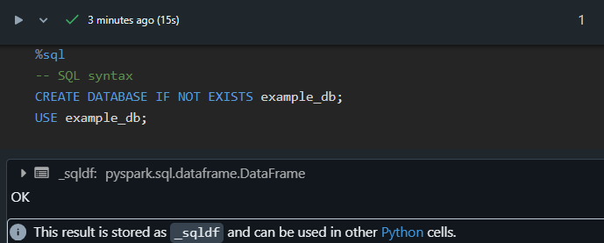

* Create a Table

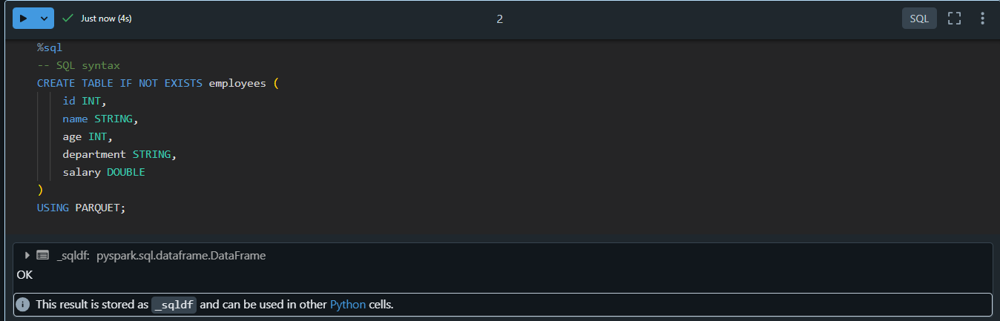

* Insert Data into the Table

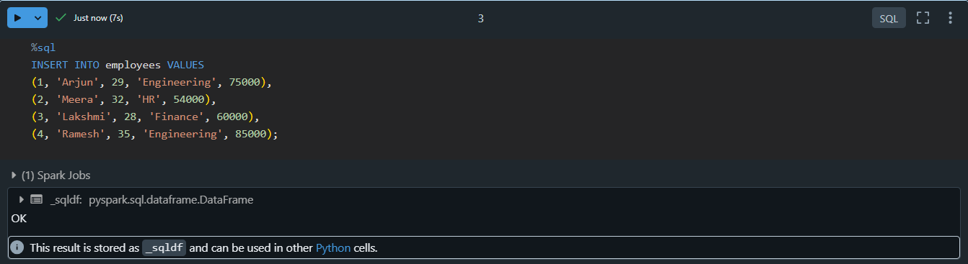

* Create Temporary Views

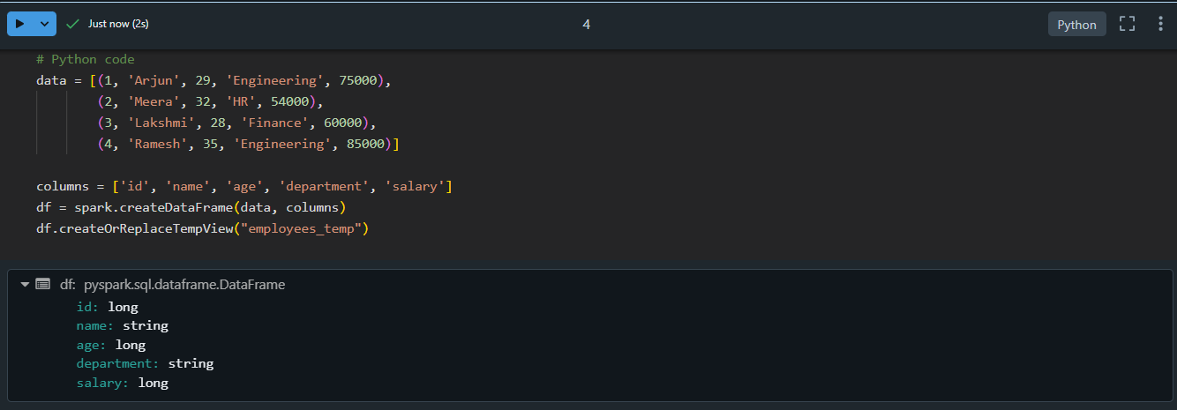

1. **Transformations**

* Filter

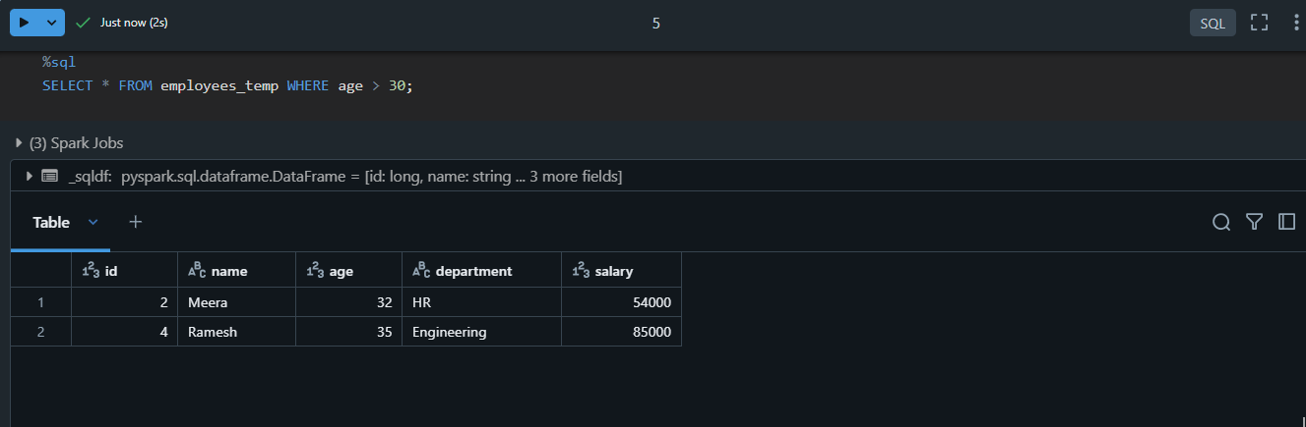

* Join

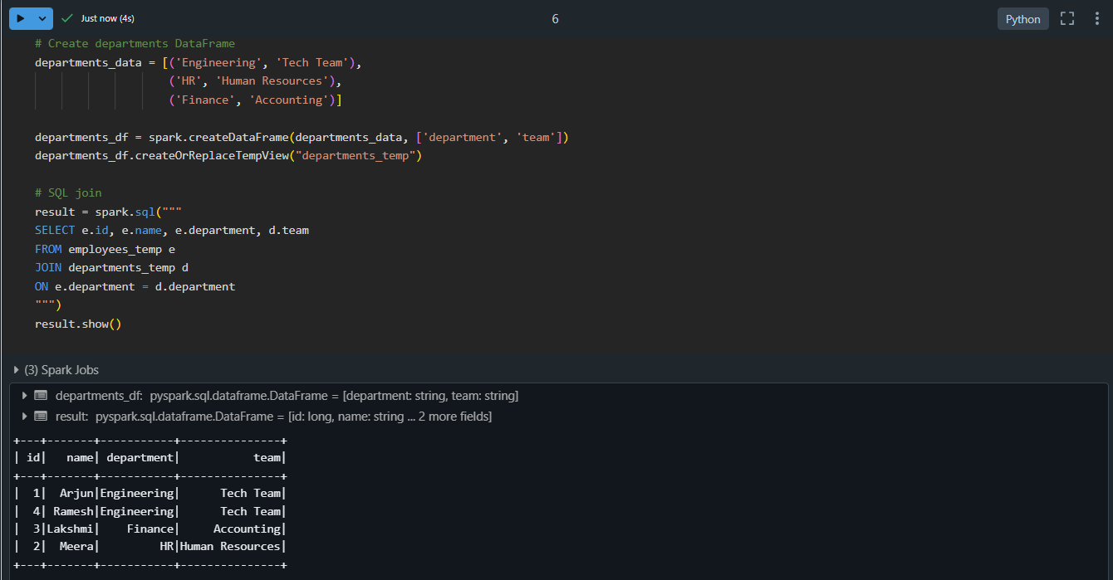

* GroupBy and Aggregations

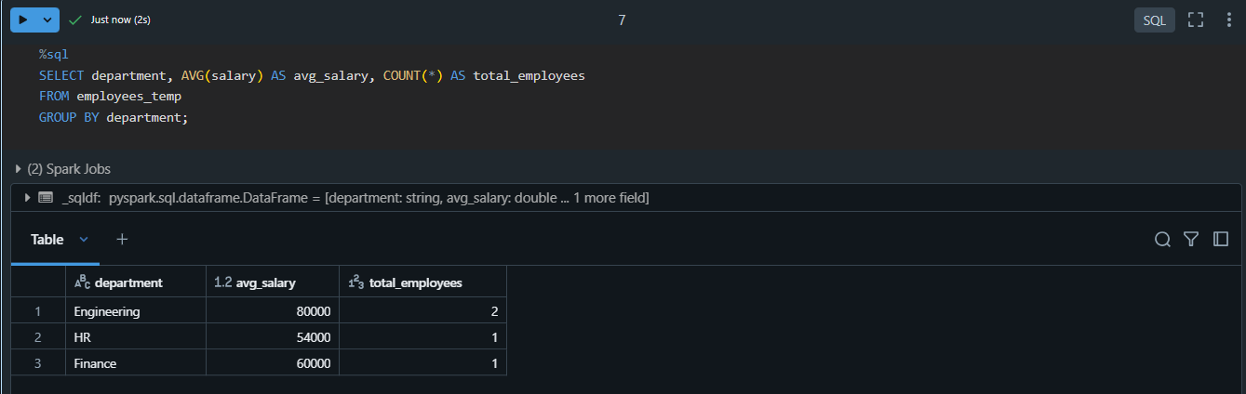

* Window Functions

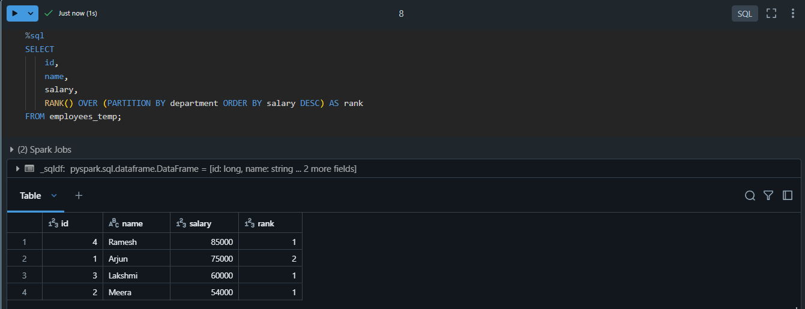

1. **Creating Local and Temporary Views**

* Create a Temporary View



* Create a Global Temporary View



* Query the Temporary View

